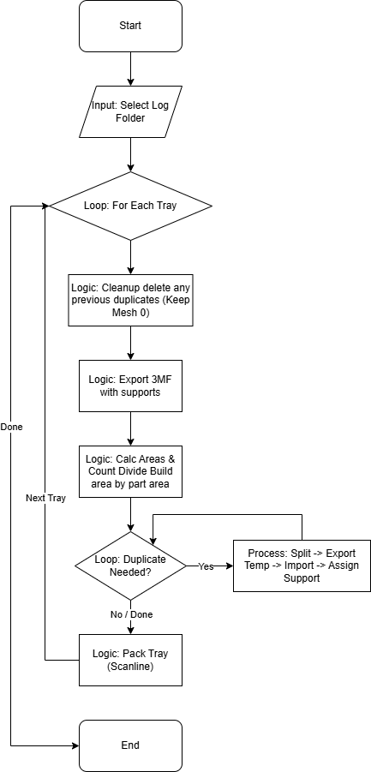
Duplicate and Arrange Script (MJ)
Script Name: duplicate_and_arrange_MJ.lua

Functionality
This script automates the production workflow by filling trays with duplicate parts until a specified density (60%) is reached. It ensures that support structures are preserved during duplication and efficiently packs the tray using a scanline algorithm.
Logic Flow:
- Cleanup: Removes all existing duplicates in the tray, keeping only the first mesh (Index 0) as the template.
- Calculation: Estimates the part's footprint (Area) and the tray's available area (assuming a cylindrical platform if configured). It calculates how many copies are needed to reach the target fill percentage.
- Duplication: Since standard duplication loses support data, the script exports the template part (with supports) to a temporary 3MF file, then iteratively imports it back into the tray to create copies with supports intact.
- Packing: Uses the 2D Scanline Packer to arrange all parts within the build platform.

User Guide (Quick Start)
- Ensure your tray contains exactly one instance of the part you want to mass-produce, with supports already applied.
- Run the script duplicate_and_arrange_MJ.
- Select a folder for the log files when prompted.
- The script will automatically duplicate the part to fill 60% of the tray area and pack them.
- Wait for the "Arrangement Complete" popup.

Code Maintenance & Technical Notes
Support Preservation: The luamesh:dupe() function does not copy support dependencies. The script solves this by splitting supports into a separate mesh, exporting both to a 3MF, and re-importing them. Do not modify this export-import loop without understanding the assignsupport mechanism.
Packing Algorithm: The script uses Scanline Packing (`packingid_2d`). Trueshape packing is avoided because it ignores "No-Build" zones, which causes collisions in cylindrical build volumes (e.g., Hyrax).
Cylindrical Math: The variable `is_cylinder` (set to `true`) forces the tray area calculation to use `pi * r^2`. Netfabb's internal bounding box logic sees the machine as a square, so this manual calculation is critical for accurate fill estimation.

